Rose Taché, Taltarni NV

Grape 53% Chardonnay, 44% Pinot Noir, 3% Pinot Meunier

Region Victoria 65%, South Australia 24%, Tasmania 11%

Winehouse Taltarni

Aroma This wine developed a nice structure and a secondary yeast character due to its time on wine lees. Aroma details of bread, which developed with a creamy textured balance.

Taste The addition of a dose of aged Pinot Noir liqueur provides an aromatic connection between strawberries and rose petals, ensuring a balance between acidity and sweetness, resulting in a really elegant sparkling rosé

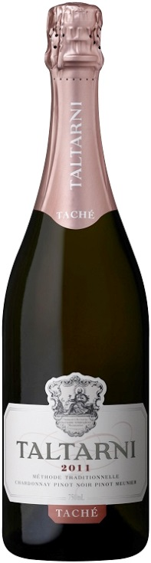
Alcohol 11,7%

